Literature Review – Assignment 2 – Contextual Studies

Introduction:

I have come to realise that the topic for this literature review is change, both on a larger, more global scale and also on an everyday scale. [When you say 'everyday scale/change', you seem to mean 'local' change. Just make it clear you are writing about place: Deptford (local) and world (global) rather than time: everyday, the past, the present, the future and their relationship with human memory, conceptions of self and national identity, hope and ambitions. Can you see how these two fundamental concepts: space/place and time are connected?] Despite the change occurring specifically in Deptford, this kind of change (both global and everyday) occurs everywhere and Deptford just happens to be my muse. Deptford is a good muse for change though: 'The neighbourhood [Deptford] seems to have been in permanent regeneration mode since Henry VIII stuck his dockyard here.’ - (Dyckhoff, 2018).

I have decided to review literature where the topic of change is key within the writing, in particular paying attention to regeneration in urban areas. My reasoning for targeting such change is because Deptford exhibits this in spades. [On one hand, it’s nice you’re using colloquial language but this is an academic essay, so it’s best to keep it written in plain, conventional English. You can use the colloquial in quotes though.] I feel too that my photographs are comprised of techniques which make this change more appreciable.

I have organised the literature review in a way that shows global shifts and more everyday change. I chose this because these types of change interact; while it is observed that larger scale change affects everyday [local] change, I’ve learnt that the everyday can also affect larger-scale shifts like regeneration. I feel there is a connection between these types of change that is evident in my photographic approach. Therefore I have also incorporated an artist whose photographic approach is very similar to mine and has inspired me for my project.

Since Deptford has a history of regeneration, I have found literature which both describes a history of Deptford and regeneration at the same time. However, as Deptford is my muse for the project and not the subject, the history of Deptford will take backstage to the focus of the review.

Texts:

Ground Control (2012) by Anna Minton:

Anna Minton describes how cities all over England are losing democracy over land use in Part 1 of Ground Control (2012). Instead they are owned by private companies; forming private estates, gated communities and public spaces which are actually privately governed. One model the government validates the privatisation of land on is the ‘trickle-down’ concept. Minton demonstrates that trickle-down doesn’t work: ‘rather than helping those who need it [wealth] the most, [you can write: ‘rather than helping those who need [wealth] the most…’ You don’t need it followed by [wealth] in brackets.] it has rubbed right up against them yet entirely ignored them, creating a segregated and disconnected patchwork.’ - (Minton, 2012: 8). Despite the trickle-down concept being just a concept and not working; ‘it [trickle-down] [Just [tickle-down] will do.] endures because of the high rates of growth it brings in good times.’ - (Minton, 2012: 9). What is particularly worrying is that many people are unaware of this shift in ownership of the land - Minton references the lack of awareness as ’social silence’ - (Minton, 2012: xiii). Because of this social silence and the leverage afforded [by ‘leverage afforded’ to you mean political and economic influence?] to these private companies, large areas of land are able to be bought and developed with only profit in mind, without much consultation with the local people. In America, similar developments in land use like private estates have caused protests and outrage with people demonstrating against them: 'while it [land assembly or compulsory purchase] raised no debate here, across the Atlantic it sparked off major national protests.’ - (Minton, 2012: 22).

I see similarities and dissimilarities with Deptford compared to a housing project in Fazakerley, Liverpool described by Minton in Part 2. The ‘consultation with residents was little more than a joke.’ and ‘despite the time and effort put into consulting with the residents, their views were not listened to.’ - (Minton, 2012: 71). Similarities with this project in comparison to redevelopment projects in Deptford are the 'Secured by Design’ ethos with lots of gated communities popping up, especially closer to Greenwich (a posh neighbouring area). Secured by Design is based on ‘defensible space’ - ‘an American design principle … coined by Oscar Newman’ - (Minton, 2012: 71). Dissimilarities are that some projects in Deptford seem to go ahead without even the pretence of consulting the local residents. [You may want to make is explicit that the social effect of this is segregation: the rich separated from the poor.]

Minton’s definition of defensible space corroborates with what I perceive happening in Deptford even today: it ‘produces isolated, often empty enclaves which promote fear rather than safety and reassurance which automatically come in busy places’. - (Hillier, 1998 cited in Minton, 2012: 72). Rather than it being solely the gated communities that are creating fear, it is the pronounced contrast between the gated communities juxtaposed with the older, more run-down estates and houses that preside in Deptford. This, for me, creates an environment of ‘them' and ‘us’ which is backed up by Hillier: ‘Research from University College London shows that ‘defensible space’ does not create safer environments, finding that residents of cul de sacs were more likely to be burgled because there isolation means they are targets.’ - (Hillier, 1998 cited in Minton, 2012: 73).

These are just some of the terms Minton refers to throughout the book but the overall sentiment is that the government handing control over to private companies to develop spaces ‘Secured by Design’ creates a climate of fear and disharmony between the wealthy and those on lower incomes. Strong and unsettling point.

Turning the Tide (1993) by Jess Steele:

Turning the Tide (1993) by Jess Steele is a history of Deptford and so large parts of it are superfluous to the literature review. However, towards the end, there are some more relevant parts about more recent regeneration in Deptford up to the date the book was written in 1993. These parts do mostly tie in with what Minton proposes has been happening in cities all over England in Ground Control (2012). In Ground Control (2012), Minton is adamant that in the Docklands: ’the spreading effect [of wealth from Canary Wharf to South Quay to Crossharbour] has continued to displace the original community, as property prices ensured new homes remained unaffordable for locals, forced to move out’ - (Minton, 2012: 8). One example in Turning the Tide (1993) does completely contradict what Minton describes occurs in the Docklands: ’The estate brought a new middle class segment to Deptford without the gentrification or widespread displacement of working class communities that we have seen in the rest of Docklands.’ - (Steele, 1993: 203). However, this was only a small part of Deptford (the Crossfield Estate) where 'students, artists, musicians, teachers and social workers’ - (Steele, 1993: 203) made up this ‘middle class’ within Crossfield. This somewhat implies the rest of Deptford fell in line with what Minton suggests happened in the Docklands. [Well spotted and clarified contradiction! Your job is to look at argument/counter-argument and to bring out inconsistencies in the arguments of both sides. If the politics of the debate is a core part of this, you should mention the decade of Thatcherism and neoliberal economics which are the key motivators of this change and the ‘trickle-down’ excuse. But this really depends on how political your dissertation becomes. But it seems difficult to ignore it.]

Other areas of Turning the Tide (1993) correlate much more with Minton’s analysis and shows that housing in Deptford falls in line with what was happening in the rest of England’s cities at least up until 1993. Some examples of this tallying with Minton’s Ground Control (2012) are: ’The right-to-buy [insert a footnote explaining what right-to-buy is] means that councils are forced to accept this situation in the homes section of the market. Public buildings on the other hand, can be left on the disposals list, quietly decaying through neglect and vandalism. - (Steele, 1993: 223). Correspondingly, Minton (2012: 115-6) writes: ‘Right to buy killed off councils’ ability to build more public housing and from this point on, first under the Conservatives and then more aggressively under successive Labour governments, the market began to enter every aspect of housing policy’. Elsewhere, Steele (1993: 228) comments about action on Deptford’s estates: ‘two of the most crucial aspects of change - accountability and consultation - seem to have progressed little.’ Minton backs this up; briefly with respect to accountability: ’the market has squeezed the notion of public good out of the state, with the result that local government is failing to represent the wishes of local people’ (Minton, 2012: xxxviii). [This is a very powerful statement and summarizes a lot in one sentence.] Minton addresses consultation more expansively including: ‘despite the time and effort put into consulting with the residents, their views were not listened to.’ - (Minton, 2012: 71). All this means that regeneration in Deptford is similar to and can be extrapolated in large parts to regeneration occurring in general in cities all over England.

Residents’ Perceptions of Neighbourhood Change and its Impacts (2010) by Nadia Bashir and John Flint:

The working paper Residents’ Perceptions of Neighbourhood Change and its Impacts by Nadia Bashir and John Flint created in 2010 assesses the impact of neighbourhood change in 6 lower-income areas using qualitative data. It looks at changing perceptions by local residents in these areas from both negative and positive perspectives. Then the paper draws conclusions based on the extensive interviews carried out as well as comparing the 6 different areas residents’ perceptions where ‘geographical location of the neighbourhood provided a key context for the impacts of neighbourhood change.’ - (Bashir and Flint, 2010: 26). This paper was one of the sources I managed to find that covered larger-scale regeneration affecting residents’ everyday lives. Although the data was purely qualitative, it provided a succinct insight into the perceptions of those locals from six different places/sites/communities.

Salient qualitative data includes one viewpoint on the/a development[s] in Hillside, Oxgangs and Wensley Fold: “We’re still living with the open areas that have been cleared of housing and I don’t think that’s very good for the morale on the estate…you’ve got this vast expanse of land where there’s nothing, it’s just open land, you can’t see it, your vision can’t penetrate it” (Barbara, aged 45-64, Hillside, 2010 cited in Bashir and Flint, 2010: 23). This was contradicted (concerning the same space) with: “Brilliant, I love it, everyone whose moved as well is from the street that I’ve lived in so it’s like the whole street moving to a load of new homes…the kids are having a great time playing out in the street and that, made loads of new friends” (Rebecca, aged 25-29, Hillside, 2010 cited in Bashir and Flint, 2010: 23). These kind of viewpoints enabled the authors to draw their conclusions which found the residents’ perceptions to be a mix of positive and negative comments but not a ‘Broken Britain’ narrative - (Bashir and Flint, 2010: 34).

One area of note was that the paper opposed the ‘broken windows’ theory proposed by Wilson and Kelling (1982). The ‘broken windows’ theory suggests that 'visible signs of physical disorder and incivilities acted as symbols of neighbourhood decline and deteriorating mechanisms of social control, which in turn resulted in residents wishing to leave the area’ - (Bashir and Flint, 2010: 2). However, Bashir and Flint found, subsequent to their interviews with residents, that: 'the majority of residents did not translate negative views of aspects of neighbourhood change into a desire to leave their neighbourhood’ because 'mobility was not an option (either due to financial constraints or a strong orientation to remain in the neighbourhood).’ - (Bashir and Flint, 2010: 24). For me this is where qualitative data is most useful because the residents (or sample of residents) clearly wanted to stay in the neighbourhood despite the deliberate neglect of property. Bashir and Flint (2010: 35) did concede: 'it is clear that environmental incivilities and degradation … have a powerful symbolic impact on residents’ perceptions of the trajectory of their neighbourhood.’ The 'broken windows’ theory is of interest to me because it is an example of how seemingly slower, less consequential change like (deliberate) neglect and thus degradation to buildings can have an effect. The effect is on a larger, more obvious scale like buildings being demolished to make way for new ones. [Clarify these two sentences and make your point.]

The Corners (2009-17) by Chris Dorley-Brown:

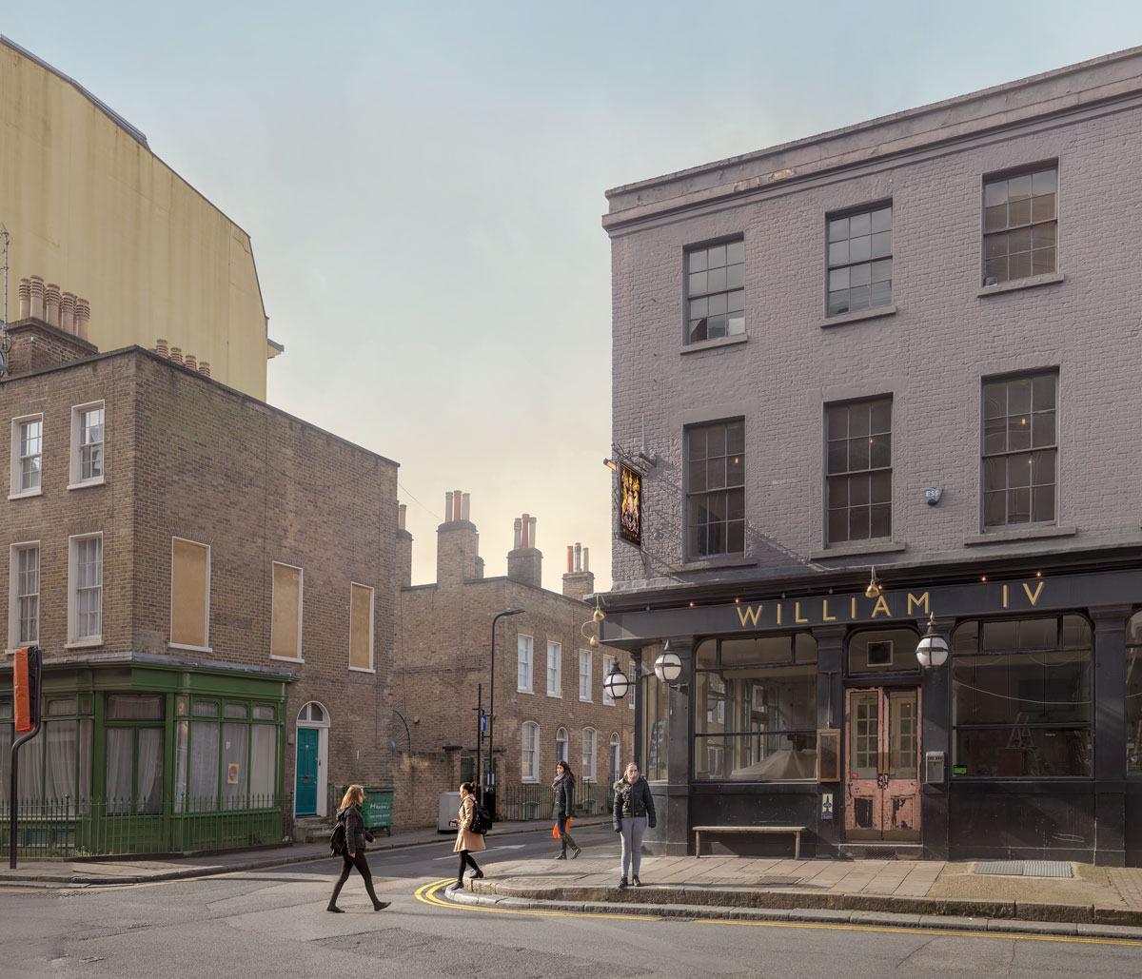
Figure 1. William IV, 2017 (2017) © Chris Dorley-Brown

Chris Dorley-Brown’s The Corners (2009-17) uses a composite technique to piece together people from different photographs in the same place to form a narrative [Do you really think there’s a narrative here? Isn’t it more a social ambience?] that would not have otherwise existed. [The Corners is not actually his best work with reference to change Continuum being the most explicit visual strategy of temporal change.] The backdrops for these composites remain consistent and they are a part of ‘the street corners of London’s east end’ - (Dorley-Brown, 2009-17). A lot of regeneration has occurred in London’s east end and so it makes a good backdrop for Dorley-Brown’s composites because it provides an interesting stage. Despite the grand landscapes with evidence of change, the people always seem to stand out in Dorley-Brown’s images. This is partly down to the composite approach but more to do with the way the people seem to be trapped in the middle of whatever ordinary activity they are conducting. This gives the photographs their timelessness: 'the pictures look like records of a fully immersive street installation that, for those lucky enough to obtain tickets, offers the experience of being able to wander through a world in which time is stalled, isolating everyone else midstride, mid-phone call, midlife.’ - (Dyer, 2018). I like this sense of timelessness that Dyer talks of but I feel the images of Dorley-Brown definitely tell in traces that they are of a particular time.

Continuum (1979-2014) by Chris Dorley-Brown:

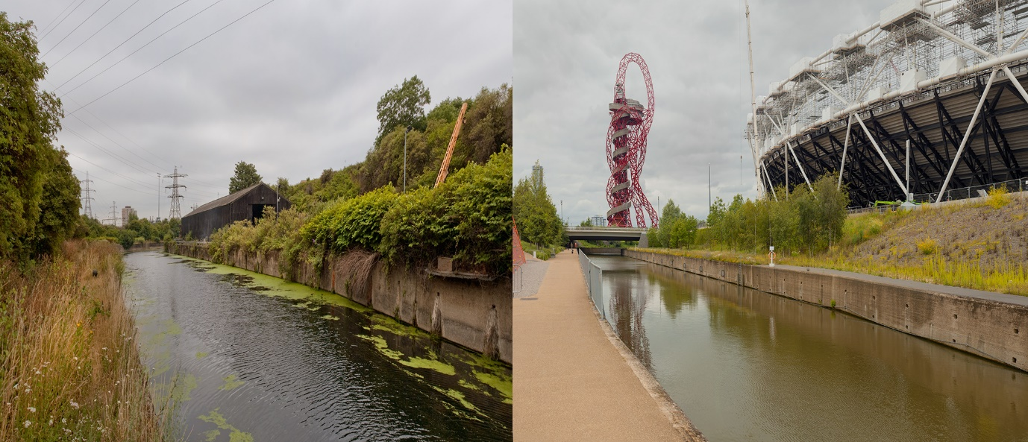
Figure 2. bow back rivers (2004-14) © Chris Dorley-Brown

Using a process called rephotography, Chris Dorley-Brown revisits places years after he has previously photographed them and takes another photograph using as similar as possible framing in Continuum (1979-2014). This process is highly effective at revealing change within a scene. Dorley-Brown describes his work process: 'the photograph is re-made and re-created with precise attention to detail’ - (Dorley-Brown, 2014). I too have found when using rephotography that framing the later shot is intrinsic in allowing the viewer to immerse themselves in any change in each image. Devoid of any distractions that might have been apparent due to dissimilar framing, I found myself able to appreciate the changes (some of which were drastic) that had taken place in the time between some of Dorley-Brown’s Continuum (1979-2014) images. I aim to use the visual change/transformations evident in Dorley-Brown’s The Corners (2009-17) [?] series and use rephotography evident across Dorley-Brown's diptychs for Continuum (1979-2014) to my own project which displays change profusely, just like my muse, Deptford does.

Conclusion:

Everyday changes [Note that this is temporal, and it could well be important, particularly if you work on a project over a long period of time like Dorley-Brown’s Continuum] may seem ephemeral and inconsequential but they interact with larger scale regeneration, affecting the types of people moving into or out of an area. One example of this that springs to mind is the ‘broken windows’ theory developed by Wilson and Kelling (1982). Vice versa, the environment these people are moving into or out of changes accordingly, with more pervasive developments having an impact on everyday changes to the landscape and people. Minton explores this in Part 1 of Ground Control (2012), with the effects the development of Canary Wharf had on neighbouring areas of the Docklands in the 1980s. One way to show these changes is through photography as the changes can manifest themselves in physical transformation of a place. The indexical properties of the photograph lend an air of authenticity as the viewer may be aware that something from real-life has been recorded: 'a specific photograph, in effect, is never distinguished from its referent’ - (Barthes, 2003: 20). These notions can be played upon like in the work of Dorley-Brown’s The Corners (2009-17) where the use of composites allows change to stand out more and at the same time to feel fixed in an instance.

I plan to use these different texts and papers to illustrate how change is affecting Deptford in my extended written project. The types of change occurring are larger-scale regeneration and seemingly inconsequential everyday changes which interact with each other. Photography, through depicting physical transformations of a place, is one way of showing the changes happening. I will then demonstrate how I have been inspired by the work of Chris Dorley-Brown with The Corners (2009-17) to make a compelling strategy incorporating people within the places. This strategy portrays simultaneously banality and timelessness through the use of a digital composite technique. The types of change depicted interact within single images and especially when compared with other images from the same scenes. I will be able to incorporate images from the same scenes through rephotography, which is one way of making change more appreciable within the project. Again this draws upon the work of Dorley-Brown, although this time from Continuum (1979-2014). By combining inspiration from Dorley-Brown’s 2 different projects, I am able to communicate change both within and across a series of images.

Word Count:

1,851, excluding quotes

2,612, with quotes

List of Illustrations:

Fig. 1 Dorley-Brown, C. (2017) William IV, 2017 [Photograph] At: https://www.huckmag.com/art-and-culture/photography-2/surreal-shots-east-londons-hidden-corners/ (Accessed 13/12/2019)

Fig. 2 Dorley-Brown, C. (2004-14) bow back rivers [Photograph] At: https://mmillmoredigitalimageandculture.home.blog/2019/06/18/chris-dorley-brown/ (Accessed 13/12/2019)

References:

Barthes, R. (2003) 'Extracts from Camera Lucida’ In: Wells, L. (eds.) The Photography Reader. Oxon: Routledge. pp.19-30.

Bashir, N. and Flint, J. (2010) 'Residents’ Perceptions of Neighbourhood Change and its Impacts’ In: Living Through Change in Challenging Neighbourhoods: A Research Project funded by the Joseph Rowntree Foundation (2) pp.1-42. At: https://research.shu.ac.uk/cresr/living-through-change/documents/RP2_NeighbourhoodChange.pdf (Accessed 12/12/2019)

Dorley-Brown, C. 1979-2014) Continuum. At: https://modrex.com/photoworks#/continuum/ (Accessed 12/12/2019)

Dorley-Brown, C. (2009-17) The Corners. At: https://modrex.com/photoworks#/the-corners/ (Accessed 12/12/2019)

Dyckhoff, T. (2018) 'Let’s move to Deptford, south-east London: love it, hate it? Worry not.' In: The Guardian [online] At: https://www.theguardian.com/money/2018/feb/09/lets-move-to-deptford-south-east-london-property-tom-dyckhoff (Accessed on 19/09/2019)

Dyer, G. (2018) How to Photograph Eternity. At: https://www.nytimes.com/2018/07/24/magazine/how-to-photograph-eternity.html (Accessed 12/12/2019)

Hillier, B. (1998) The Common Language of Space: A Way of Looking at the Social, Economic and Environmental Functioning of Cities on a Common Basis. In: Minton, A. (2012) Ground Control. (2nd ed.) London: Penguin Books Ltd.

Minton, A. (2012) Ground Control. (2nd ed.) London: Penguin Books Ltd.

Steele, J. (1993) Turning the Tide. London: Deptford Forum Publishing Ltd.

Wilson, J.Q. and Kelling, G. (1982) ‘Broken Windows: The police and neighbourhood safety, The Atlantic Monthly, March 1982, pp. 29-37.

Bibliography:

Barthes, R. (2003) 'Extracts from Camera Lucida’ In: Wells, L. (eds.) The Photography Reader. Oxon: Routledge. pp.19-30.

Bashir, N. and Flint, J. (2010) 'Residents’ Perceptions of Neighbourhood Change and its Impacts’ In: Living Through Change in Challenging Neighbourhoods: A Research Project funded by the Joseph Rowntree Foundation (2) pp.1-42. At: https://research.shu.ac.uk/cresr/living-through-change/documents/RP2_NeighbourhoodChange.pdf (Accessed 12/12/2019)

Bourton, L. (2018) Chris Dorley-Brown’s sharp images of East London are actually made up of many multiple shots. At: https://www.itsnicethat.com/articles/chris-dorley-brown-the-corners-hoxton-mini-press-photography-090718 (Accessed 13/12/2019)

Davidson, L. (2018) Chris Dorley-Brown, The Corners. At: https://www.we-heart.com/2018/07/05/chris-dorley-brown-the-corners/ (Accessed 13/12/2019)

Dean, P. (2011) London Street Corners Photographed by Chris Dorley-Brown. At: https://www.featureshoot.com/2011/11/london-street-corners-photographed-by-chris-dorley-brown/ (Accessed 13/12/2019)

Dorley-Brown, C. 1979-2014) Continuum. At: https://modrex.com/photoworks#/continuum/ (Accessed 12/12/2019)

Dorley-Brown, C. (2009-17) The Corners. At: https://modrex.com/photoworks#/the-corners/ (Accessed 12/12/2019)

Dyckhoff, T. (2018) 'Let’s move to Deptford, south-east London: love it, hate it? Worry not.' In: The Guardian [online] At: https://www.theguardian.com/money/2018/feb/09/lets-move-to-deptford-south-east-london-property-tom-dyckhoff (Accessed on 19/09/2019)

Dyer, G. (2018) How to Photograph Eternity. At: https://www.nytimes.com/2018/07/24/magazine/how-to-photograph-eternity.html (Accessed 12/12/2019)

Flynn, N. (2018) Surreal shots of East London’s hidden corners. At: https://www.huckmag.com/art-and-culture/photography-2/surreal-shots-east-londons-hidden-corners/ (Accessed 28/11/2019)

Hillier, B. (1998) The Common Language of Space: A Way of Looking at the Social, Economic and Environmental Functioning of Cities on a Common Basis. In: Minton, A. (2012) Ground Control. (2nd ed.) London: Penguin Books Ltd.

Lees, L. (2013) Regeneration in London has pushed poor families out. At: https://www.theguardian.com/local-government-network/2013/aug/29/mixed-communities-plan-government-regeneration (Accessed 13/12/2019)

Minton, A. (2012) Ground Control. (2nd ed.) London: Penguin Books Ltd.

Pethia, S.R. (2011) Reconstructing Communities: the impact of regeneration on community dynamics and processes. [PhD thesis] The University of Birmingham. At: https://etheses.bham.ac.uk/id/eprint/3118/1/Pethia11PhD.pdf (Accessed 13/12/2019)

Schifferes, J. (2018) What Ever Happened to Regeneration? At: https://www.thersa.org/discover/publications-and-articles/rsa-blogs/2018/05/what-ever-happened-to-regeneration (Accessed 13/12/2019)

Sheringham, M. (2008) ‘Configuring the Everyday’ In: Johnstone, S. (eds.) The Everyday. London: The Whitechapel Gallery and MIT Press. pp.141-147.

Smith, M.K. (2011) ‘Neighborhoods and regeneration. Theory, practice, issues’ In: the encyclopaedia of informal education At: http://infed.org/mobi/neighborhoods-and-regeneration-theory-practice-issues/ (Accessed 13/12/2019)

Smyth, D. (2018) Chris Dorley-Brown’s singular vision of East End London. At: https://www.bjp-online.com/2018/05/dorley-brown-corners/ (Accessed 13/12/2019)

Steele, J. (1993) Turning the Tide. London: Deptford Forum Publishing Ltd.

Waring, A. (2018) Chris Dorley-Brown mixes reportage and architectural photography for amazing montages of street scenes. At: https://www.digitalcameraworld.com/features/chris-dorley-brown-mixes-reportage-and-architectural-photography-for-amazing-montages-of-street-scenes (Accessed 13/12/2019)

Williams. E. (2018) A fresh look at London’s street corners. At: https://www.creativereview.co.uk/a-fresh-look-at-londons-street-corners/ (Accessed 13/12/2019)

Williams, R. (2016) The Country and the City. (2nd ed.) London: Vintage.

Wilson, J.Q. and Kelling, G. (1982) ‘Broken Windows: The police and neighbourhood safety, The Atlantic Monthly, March 1982, pp. 29-37.

